North Scottsdale Secondary Bathroom Spec
  - Shared Secondary Bathroom | Desert-Modern Finish Scope + Workmanship Standard
Prepared for contractor and interior design bid alignment | June 07, 2026
Project Thesis
Renovate the shared secondary bathroom into a clean, durable, warm desert-modern bath that feels cohesive with the rest of the North Scottsdale remodel. Keep the existing fixture flow unless a field-verified improvement is simple and high-value: alcove tub/shower, single storage vanity, toilet, mirror, exhaust fan, new window, improved lighting, new tile, new plumbing fixtures, repaired walls/ceiling, and refreshed linen/storage. This is a high-quality secondary bath, not a costly custom showpiece.
Approximate room size: 8.5 ft long x 7.5 ft wide, including the small closet/storage area and tub/shower zone. All dimensions, wall conditions, plumbing locations, window conditions, and door swing must be field verified before final pricing or construction.

1. Existing Condition + Planning Basis
The existing bathroom is a compact shared secondary bath with dated floor tile, dated vanity/mirror/light bar, toilet, tub/shower alcove, window, and wall/ceiling finish issues. The renovation should maintain the basic flow and location of fixtures unless the contractor/designer identifies a simple improvement that improves function without bloating cost.
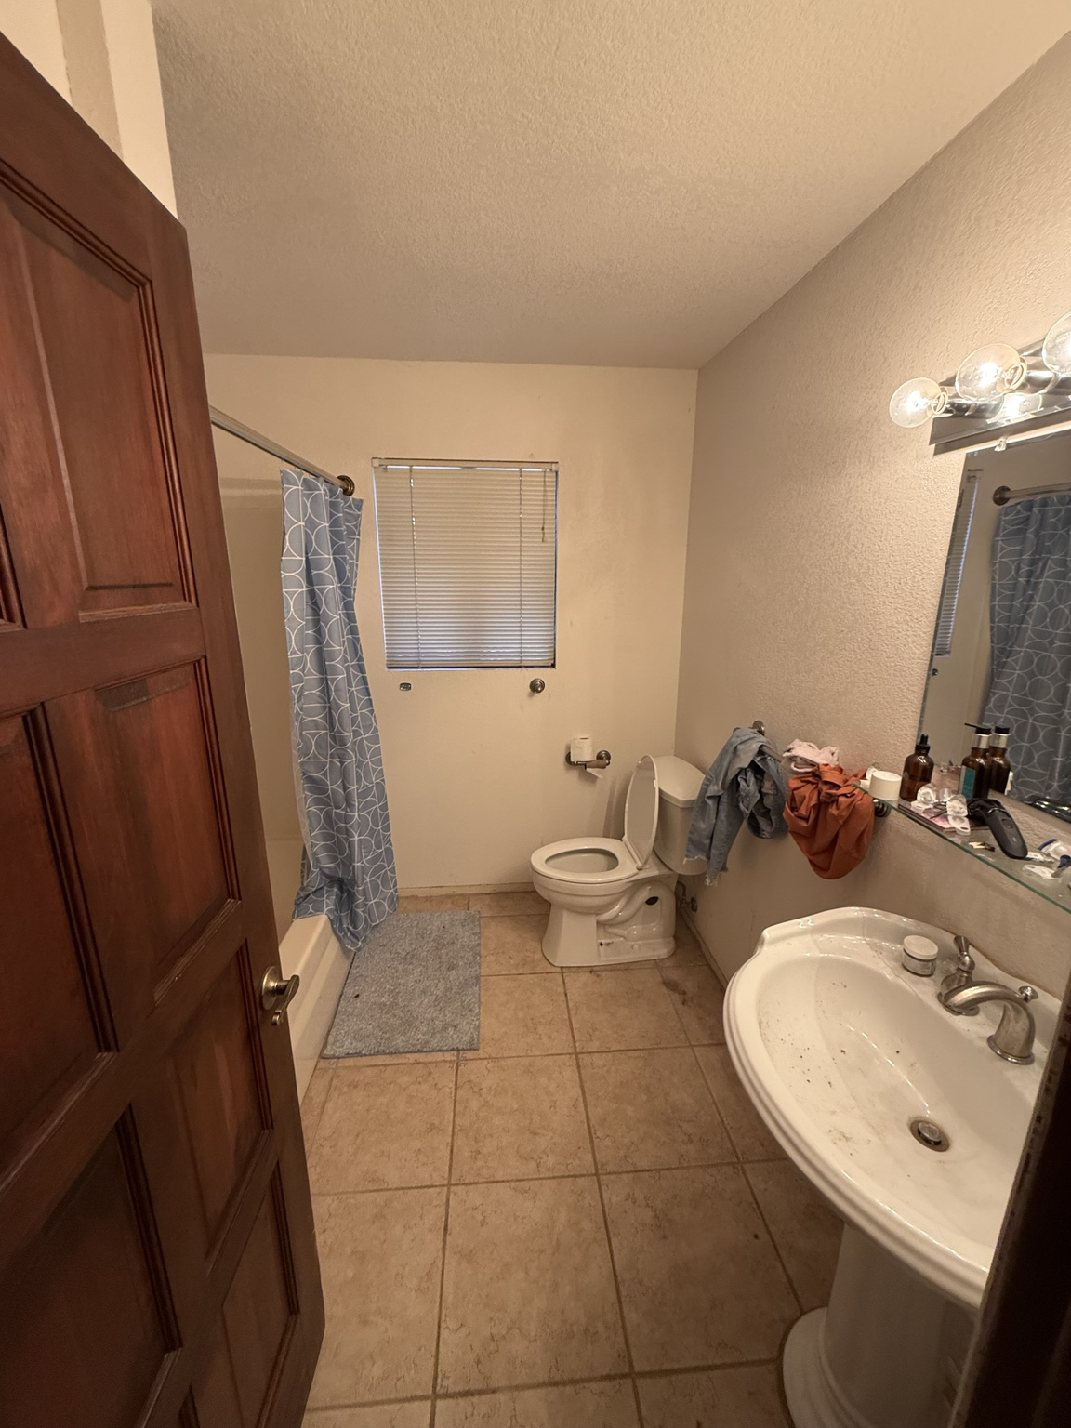
Existing secondary bathroom reference photo. Use for orientation only; field verify dimensions and conditions.
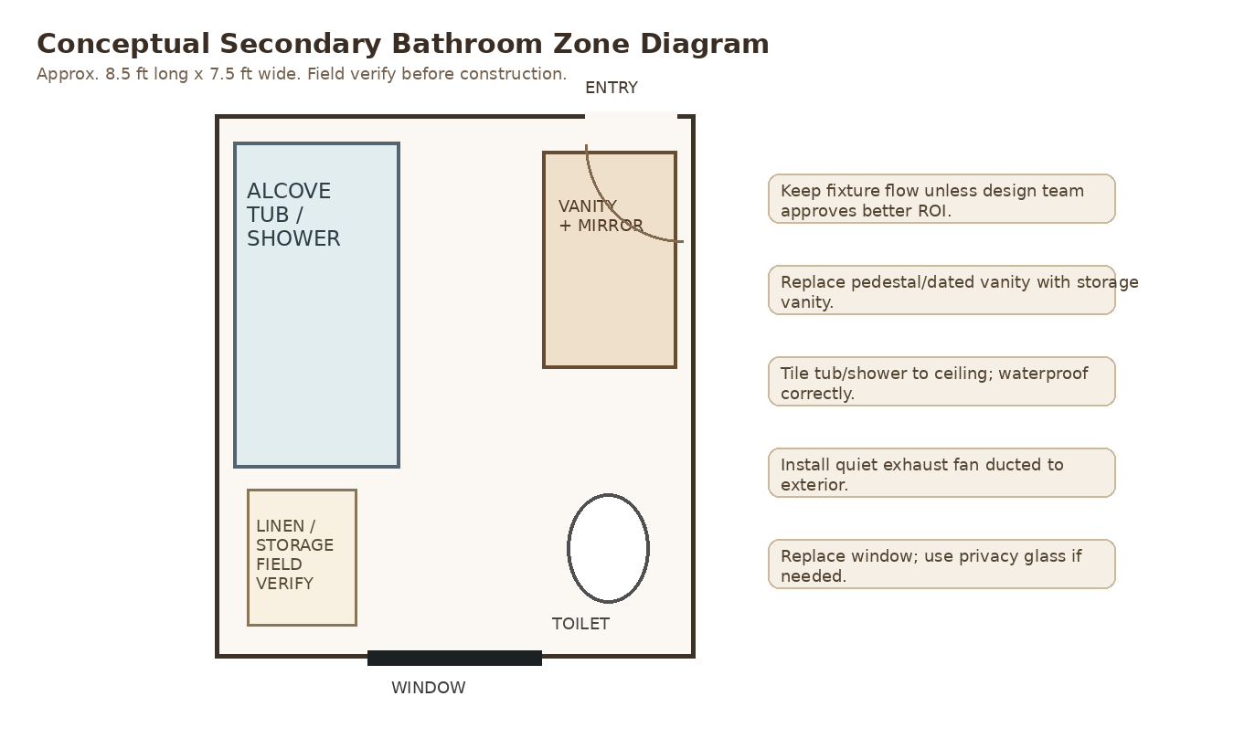
Conceptual zone diagram. Not a construction drawing.

2. Executive Summary
This bathroom should support the overall desert-modern product without stealing budget from the primary suite, kitchen, or main living zone. The correct strategy is a disciplined, premium-feeling refresh: better layout clarity, durable tile, storage vanity, strong lighting, proper ventilation, new window, warm stone palette, and excellent workmanship.
Decision Area | Base Direction
Layout | Keep existing fixture flow: tub/shower alcove, vanity, toilet, window, linen/storage. Move plumbing only if field conditions show a low-cost/high-value improvement.
Design Level | Warm, clean, high-end secondary bath. More elevated than rental-grade, less custom than primary ensuite.
ARV Priority | Make the room feel fresh, hygienic, durable, and cohesive. Avoid overbuilding; spend on tile execution, vanity storage, lighting, fan, window, and waterproofing.
Tub/Shower | Replace with new alcove tub + tile surround to ceiling. Price semi-frameless tub glass as an alternate; base may use premium shower rod/curtain if desired.
Vanity | Replace pedestal/dated vanity with storage vanity and quartz/stone-look top. Use warm wood or warm painted finish.
Ventilation | Install quiet exhaust fan ducted to exterior. Do not vent to attic/cavity.

Design intent
- Same overall palette as the rest of the house: warm limestone, bone, sand, soft taupe, white oak/walnut, bronze or blackened metal accents.
- No gray flip palette, no heavy Tuscan, no farmhouse, no cheap glossy builder tile, no ornate vanity lights.
- The bath should photograph cleanly for resale and function well for guests, kids, or secondary bedrooms.

3. Base Scope of Work
Contractor shall price the following as the base bid. All final selections to be confirmed by owner/interior designer before ordering.
Scope Item | Required Work
Demo + Prep | Remove existing vanity/sink/faucet, mirror, light fixture, toilet, tub/shower finishes as required, floor tile as required, old accessories, damaged drywall/trim, blinds/window treatment, and debris. Protect adjacent bedrooms/hall.
Tub/Shower Alcove | Install new white alcove tub; new tub/shower valve, tub spout, shower head, and optional handheld. Install cementitious/foam backer + complete waterproofing, then tile to ceiling.
Flooring | Install matte warm stone-look porcelain tile or approved coordinating bathroom tile. Include slab/substrate prep, crack treatment where needed, consistent grout joints, and clean transitions.
Vanity | Install new storage vanity, countertop, sink, faucet, drain, shutoffs, and hardware. Vanity should improve storage and replace the dated pedestal condition.
Mirror + Lighting | Replace mirror with framed or pill/rounded rectangle mirror or medicine cabinet. Replace light bar with designer-approved vanity lighting. Add dimmer where appropriate.
Toilet | Install new elongated comfort-height toilet, preferably skirted or clean-profile. Reuse existing location unless approved otherwise.
Exhaust Fan | Install quiet fan ducted to exterior. Include switch control, roof/wall cap as required, and patching.
Window | Replace existing window with product consistent with the rest of the remodel. Use obscured/privacy glass if needed. Include flashing/waterproofing and clean interior return.
Walls/Ceiling/Paint | Repair walls/ceiling, remove or blend old texture, prime, and paint in warm moisture-resistant finish. Ceiling to receive bath-appropriate paint.
Linen/Storage | Refresh existing small closet/storage: repair, paint, new shelves/rod as applicable, new door/hardware if needed. Do not eliminate storage without written approval.
Trim/Hardware/Accessories | Install new baseboards/trim, door hardware, towel bars/hooks, toilet paper holder, robe hook, and any required blocking. Finish must coordinate with rest of house.
Cleanup/Punch | Final clean, grout haze removal, fixture testing, caulk review, punch-list completion, and turnover of product/warranty information.

4. Layout + Design Direction

Base layout
Base layout keeps fixture positions generally in place. This is the correct ROI assumption because the bathroom is compact and shared; moving plumbing is only justified if it materially improves function, clearances, or window/vanity/tub layout without cascading cost.
Element | Design Standard
Tub/shower | Alcove tub/shower on existing tub wall. Tile to ceiling for a more expensive, cleaner look.
Vanity | Single storage vanity on existing vanity wall. Target 36-48 in. wide, field verify. Prioritize drawers/storage over a decorative pedestal.
Toilet | Keep existing location if clearances are code-compliant. Use new elongated comfort-height toilet.
Window | Replace and integrate cleanly; use privacy glass/blind strategy as needed.
Closet/storage | Refresh and keep useful. This bath needs storage because it serves the secondary bedrooms.

Recommended finish direction
Use a simplified version of the house-wide Sonoran Resort Modern palette: warm limestone-look tile, smooth warm walls, white oak or warm painted vanity, matte black/bronze/brushed nickel fixtures, quiet lighting, and minimal visual clutter.

5. Material + Finish Schedule
Item | Specification
Floor Tile | Matte porcelain, warm limestone/sand/taupe tone. Suggested sizes: 12x24, 24x24, or 24x48 depending on layout. Slip-resistant bathroom-appropriate finish. Avoid glossy or gray tile.
Shower Wall Tile | Matte porcelain or ceramic in warm stone/off-white tone. Tile to ceiling. Large-format stacked/grid layout preferred; subtle handmade-look tile acceptable only if it stays calm and timeless.
Grout | Color-matched warm neutral. Tight, consistent joints. No high-contrast grout unless approved.
Vanity | Warm white oak, walnut, mushroom/taupe painted, or clean warm white. Storage drawers preferred. No ornate raised-panel Tuscan vanity.
Countertop | Quartz or quartzite-look surface in warm white/limestone tone. Integrated or undermount sink. Avoid busy speckled granite.
Plumbing Fixtures | Brushed nickel, polished nickel, blackened bronze, matte black, or warm bronze. Use one finish family consistently.
Mirror | Framed rectangle, rounded rectangle, pill mirror, or recessed medicine cabinet. Size proportional to vanity; not builder-grade plate glass by default.
Lighting | Warm 2700K-3000K vanity lighting; dimmer preferred. No exposed-bulb Hollywood strip.
Walls | Warm off-white/bone/sand washable bath paint over repaired smooth or lightly refined texture.
Ceiling | Moisture-resistant flat/matte bath paint. Patch around fan/light cleanly.
Trim | Simple flat-stock base/door casing or consistent trim package with bedroom wing. Paint warm white or wall-coordinated tone.

6. Fixture-by-Fixture Specifications

Alcove tub + shower
- New white alcove tub, likely 60 in. x 30/32 in. subject to actual rough opening. Use a clean rectangular profile rather than a cheap rounded builder tub if budget allows.
- Tile surround to ceiling. This single move makes a compact secondary bath feel much more complete and expensive.
- Install waterproof backer/membrane system behind tile. No drywall/greenboard as the tile substrate in the wet zone.
- Integrate tub flange properly with waterproofing. Corners and changes of plane receive appropriate sealant, not hard grout.
- Provide shower niche only if it can be laid out cleanly with tile module; otherwise use a clean corner shelf or ledge solution. No random crooked niche.
- Price semi-frameless tub glass/sliding enclosure as an alternate. Base may use a premium rod/curtain if that better supports practical family use.

Vanity wall
- Replace existing dated sink/vanity condition with a storage vanity. Storage matters more here than decorative legs or pedestal aesthetics.
- Target vanity width: 36-48 in., field verify based on toilet clearance, door swing, and circulation.
- Countertop: warm quartz/quartzite-look surface with undermount or integrated sink.
- Faucet centered and aligned; supply/drain lines concealed neatly and must not interfere with drawers.
- Mirror centered to vanity. If additional storage is needed, use a recessed or framed medicine cabinet that still looks intentional.

Toilet + clearances
- New elongated comfort-height toilet, white, clean-profile. Skirted toilet preferred if budget allows.
- Maintain code-required clearances. Contractor shall verify rough-in and side/front clearances before ordering.
- Install new wax ring/seal, shutoff, supply line, and seat. Toilet must be level, stable, and leak-free.

Window + privacy
- Replace existing window with frame/color consistent with the rest of the house, ideally dark bronze/black or approved matching package.
- Use low-E glass and tempered/obscured/privacy glass if required by code or privacy conditions.
- Interior sill/return must be moisture-appropriate and cleanly integrated. Exterior flashing/stucco patch must be included.

7. Workmanship Standards / Rejection Criteria
Work is not accepted simply because it is installed. It must be installed cleanly, aligned, waterproofed, and consistent with the design standard.
Area | Acceptance Standard
Tile Layout | Layout approved before setting. No visible sliver cuts at tub edge, window, vanity wall, or floor entry. Grout joints straight and consistent.
Tile Install | No spot-bonding. Proper mortar/trowel/back-butter method for tile size. No hollow tiles, obvious lippage, crooked rows, or grout haze.
Waterproofing | Complete waterproofing at tub/shower walls, corners, penetrations, niche/ledge if used, and tub flange integration. No tile over drywall in wet zone.
Caulk/Sealant | Color-matched flexible sealant at corners and changes of plane. Clean lines. No smeared caulk or hard grout in movement joints.
Fan/Vent | Fan ducted to exterior. Not into attic/cavity. Quiet operation, clean grille alignment, no rough ceiling patch.
Vanity | Level, plumb, doors/drawers aligned, no damaged finish, faucet centered, plumbing does not block drawers.
Mirror/Lighting | Mirror and light centered and aligned to vanity. No exposed wiring, no crooked fixture, no old light bar condition.
Paint/Drywall | No visible patch lines, texture mismatch, drips, roller marks, or paint flashing. Moisture-appropriate paint in bath.
Door/Window | Window plumb/square, flashed, smooth operation, clean stucco/interior patch. Door/hardware aligned and consistent with bedroom wing.

Specifically prohibited shortcuts
- Installing tile over old tile, dirty substrate, loose thinset, or unprepped slab.
- Using drywall/greenboard as the wet-zone tile substrate.
- Skipping waterproofing at tub flange, corners, penetrations, or niche/ledge.
- Using mastic in wet tub/shower areas.
- Calling orange peel or patchy texture a finished smooth wall.
- Venting exhaust fan into attic or wall cavity.
- Reusing the old builder light bar or mirror unless owner specifically approves.
- Installing a pedestal vanity that provides no storage unless owner approves.
- Substituting cheaper fixtures/tile/vanity without written approval.

8. Required Bid Breakdown + Allowances
Contractor shall price the secondary bathroom separately from bedrooms, primary suite, and kitchen work. Bid must identify labor, material allowances, exclusions, and alternates clearly enough for comparison.
Bid Line Item | Must Be Included / Clarified
Demo + haul-off | Bathroom demo, debris removal, protection of adjacent areas.
Tub | Tub product allowance, rough plumbing, installation.
Shower valve/trim | Fixture allowance, finish, installation.
Waterproofing | System/material included and wet-zone area included.
Shower wall tile | Tile material allowance, setting labor, grout, edge trim.
Floor tile | Tile allowance, slab prep, setting, grout, transitions.
Vanity/counter/sink/faucet | Product allowance and installation.
Toilet | Product allowance and installation.
Mirror/medicine cabinet | Product allowance and installation.
Lighting/electrical | Vanity light, switch/dimmer, GFCI, shower light if included.
Exhaust fan | Fan product, ducting to exterior, roof/wall cap, patching.
Window | Window product, privacy glass if needed, flashing, stucco/interior patch.
Walls/ceiling/paint | Drywall repair, texture/smooth finish, primer, paint.
Closet/storage | Shelving, paint, hardware, door treatment if included.
Accessories | Towel bars/hooks, toilet paper holder, robe hooks, blocking.

Required allowances
Allowance Item | Amount
Alcove tub | $____
Shower/tub valve + trim | $____
Shower wall tile | $____ / sf
Bathroom floor tile | $____ / sf
Waterproofing system | $____
Vanity cabinet | $____
Vanity countertop/sink | $____
Faucet | $____
Toilet | $____
Mirror / medicine cabinet | $____
Vanity light | $____
Exhaust fan | $____
Window | $____
Accessories/hardware | $____

9. Required Hold Points
- Layout confirmation: confirm tub, vanity, toilet, window, linen/storage, door swing, accessories, and clearances before ordering.
- Post-demo review: review exposed framing, plumbing, window condition, and substrate before rebuilding.
- Rough-in review: plumbing, electrical, fan ducting, window rough opening, and blocking verified before closing walls.
- Waterproofing review: tub/shower wall waterproofing inspected before tile.
- Tile layout approval: wall and floor tile layout approved before setting.
- Pre-grout check: tile alignment, cuts, lippage, niche/trim, and edge profiles reviewed before grout.
- Final punch: verify water test, drain, toilet stability, fan operation, lights, outlet, paint, caulk, grout haze, and accessories before final payment.

10. Alternates to Price Separately
- Semi-frameless or frameless tub/shower glass enclosure.
- Premium handmade-look or designer tile upgrade.
- Full-height slab or porcelain panel at tub/shower walls.
- Recessed medicine cabinet instead of surface mirror.
- Heated floor mat if owner wants comfort upgrade.
- Relocation of toilet/vanity/tub plumbing if design team identifies a material layout improvement.
- Custom linen cabinet or built-in storage upgrade.

11. Final Acceptance Standard
Final payment should not be released until the bathroom is fully complete, clean, operational, and punched out. The finished bath must look consistent with the rest of the desert-modern renovation and must not show contractor shortcuts.
Acceptance Area | Requirement
Function | All fixtures operate correctly; no leaks; toilet stable; fan exhausts exterior; outlets/switches work; window operates.
Finish | Tile flat/aligned; grout clean; caulk lines straight; no grout haze; no chipped tile; no visible wall patches.
Design | Warm desert-modern palette; storage vanity; clean mirror/light; no old Tuscan/builder-grade visual remnants.
Documentation | Product info, warranty cards, permits/inspection closeout where applicable, and care instructions turned over.
Contractor Acknowledgment
Contractor shall acknowledge that this bid is based on this scope, workmanship standard, required hold points, allowances, and rejection criteria. Any exclusions or substitutions must be listed in writing. Anything not excluded in writing is assumed included.

